**Lesson 8 Demo 5**

**Create a Persistent Storage in an AKS Cluster**



**Steps to be followed:**

1. Creating a PersistentVolume
2. Creating a PersistentVolumeClaim bound to the PersistentVolume

**Step 1: Creating a PersistentVolume**

1. Go to the **Storage** section in **SL-Cluster**, select **Persistent volumes** tab, and click on the **Add** button

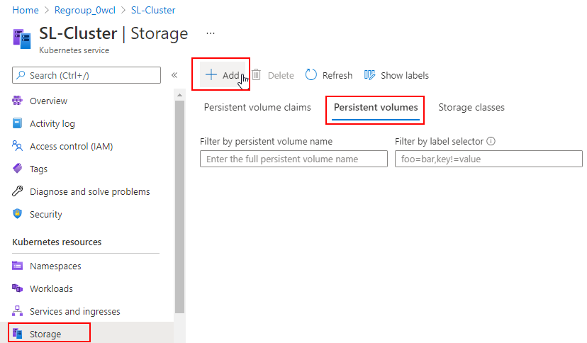

1. Add the following code to the **YAML** section and click on the **Add** button:

***apiVersion: v1***

***kind: PersistentVolume***

***metadata:***

***name: pv-volume***

***namespace: first-namespace***

***labels:***

***type: local***

***spec:***

***storageClassName: manual***

***capacity:***

***storage: 10Gi***

***accessModes:***

***- ReadWriteOnce***

***hostPath:***

***path: "/mnt/data"***

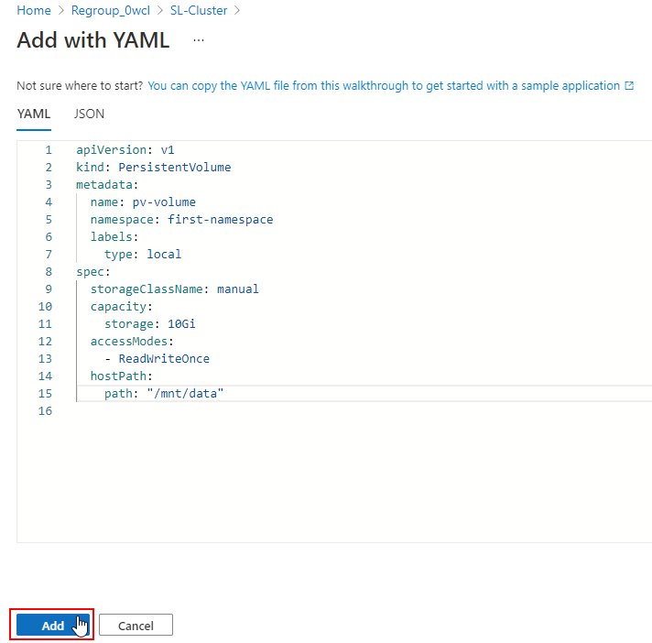

1. Check the newly created **pv-volume** under the **Persistent volumes** tab

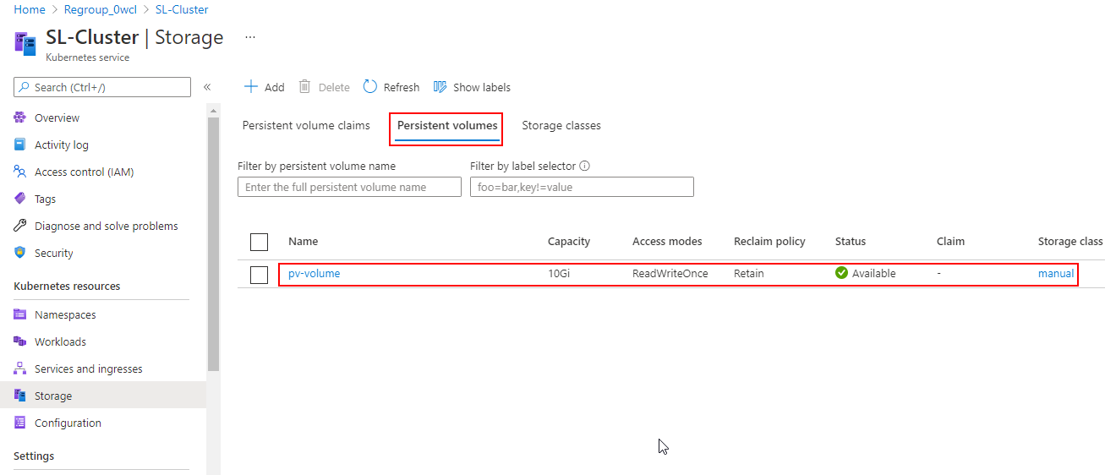

| **Note:** Notice that the **Status** of the **pv-volume** is **Available** and no claim is bound to it |
| --- |

**Step 2: Creating a PersistentVolumeClaim bound to the PersistentVolume**

1. In the **Storage** section of **SL-Cluster**, select **Persistent volumes claims** tab and click on the **Add** button

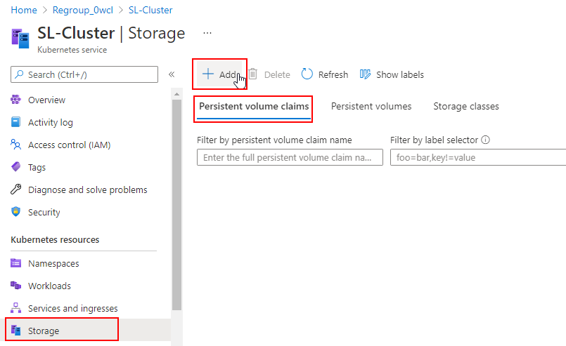

1. Add the following code to the **YAML** section and click on the **Add** button:

***apiVersion: v1***

***kind: PersistentVolumeClaim***

***metadata:***

***name: pv-claim***

***namespace: first-namespace***

***spec:***

***storageClassName: manual***

***accessModes:***

***- ReadWriteOnce***

***resources:***

***requests:***

***storage: 3Gi***

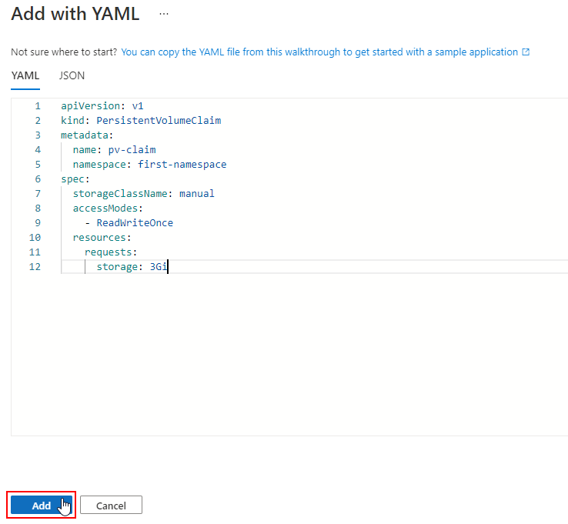

1. Check the newly created **pv-claim** under the **Persistent volumes claims** tab

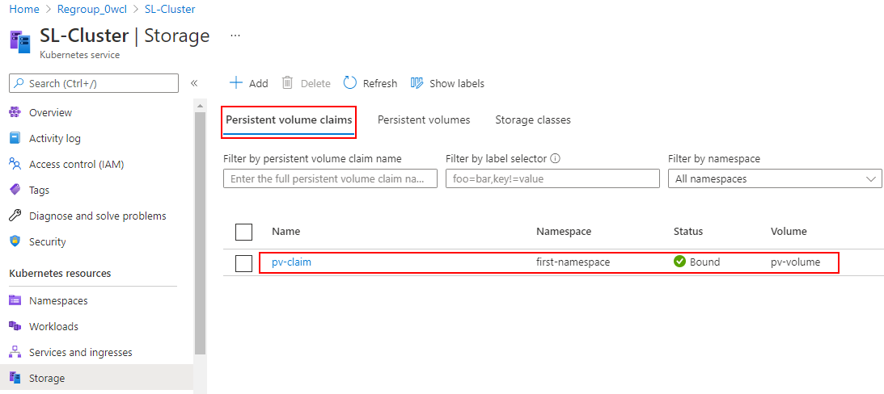

1. Navigate back to the **Persistent volumes** tab and check the **Status** and **Claim** for **pv-volume**

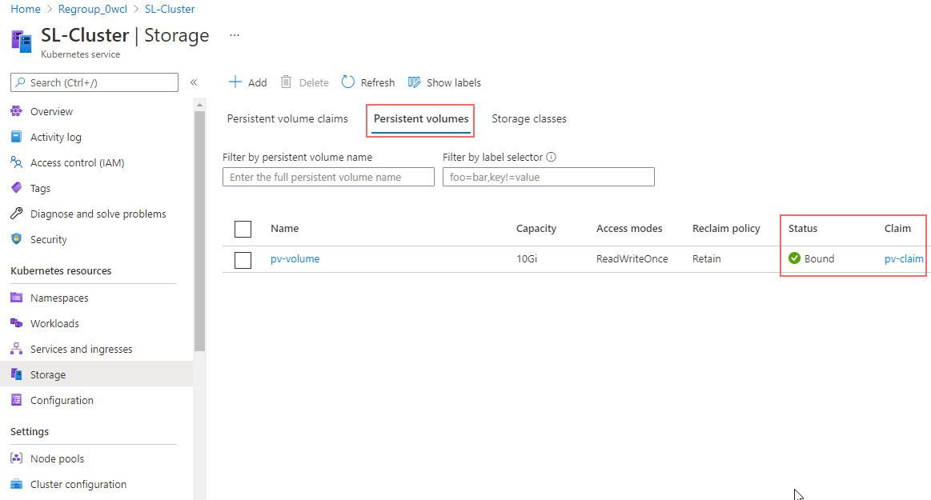

| **Note:** Notice that the **Status** is changed to **Bound** and **Claim** is changed to **pv-claim** for **pv-volume** |
| --- |